

**FORM 3**

**DEADLINE: 5 April 2024**

Please Return this Form to:

**Pico IES Group, A Division of Pico International (HK) Ltd.**

Pico House, 4 Dai Fu Street,

Tai Po Industrial Estate, New Territories, Hong Kong Fax: (852) 2667 7178

Contact person: Bel Tam Tel: (852)2660-4500 Email: [bel.tam@pico.com](mailto:bel.tam@pico.com)

Contact person: Annie Chau Tel: (852)2660-4557 Email: [annie.chau@pico.com](mailto:annie.chau@pico.com)

**SERVICE LOCATION PLAN - COMPULSORY**

1. Orders are valid only when accompanied by full remittance. Payment could be made by Hong Kong local cheque, bank draft, telegraphic transfer (See Payment Details)

2. Please note that withholding & government taxes, if any, shall be borne by the client. Invoices will be subjected to the relevant bank charges.

3. Amount paid are non-refundable for cancellation received after **5 April 2024.**

**This form must be completed and returned by all Exhibitors. (Please type / write in block letters.)**

1. Indicate clearly the location of your utilities such as power outlets, spotlights, water and compressed air on this Form.

2. It is imperative that you complete this Form as it will be used to install your requirements at the correct locations before you arrive on-site.

3. Please ensure that the positions of the lights are on the wall or fascia (unless your booth has an interior structure to which the lights can be

attached).

4. If the location plan of any service is not submitted with the order form before the stated deadline, it will be placed at the discretion of the Official

Contractor.

**Important Note**

1. Light boxes are charged accordingly to the number of tubes in each light box, using the light connection or 40W fluorescent tube rate, whichever applicable.

2. If lighting fittings are brought in by the exhibitors for lighting purposes, the lighting connection charges will apply on per bulb/per tube

basis.

3. All electrical connection to equipment must be tested and approved by the Organizer’s appointed licensed engineer prior to the turning on of the power supply. The Organizer reserves the right to terminate the power supply to any installation which are found dangerous or may cause any disruption to the power supply.

Top Elevation (3mW x 3mD)

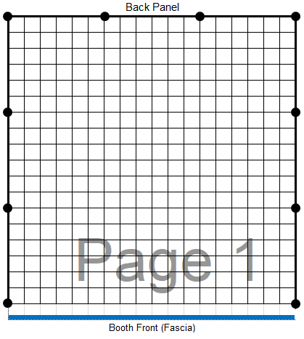

**Company Name: ____________________________________________________________ Stand No: _____________________________________**

**Address: _________________________________________________________________________________________________________________**

**Tel: ___________________________ Fax: ____________________________ Email: ____________________________________________________**

**Authorized By: ________________________________ Signature: _______________________________ Date: _________________________**